

Disaster Recovery Plan

Classification: **Internal**

This document may not be shared externally without written approval from the document owner.

|  |  |  |  |  |  |  |
| --- | --- | --- | --- | --- | --- | --- |
| Version | Approved By | Owner | Date Last Updated | Review Frequency | Next Review | Comments |
|  |  |  |  |  |  |  |

Contents

Purpose of Document 2

Policy 2

Scope 2

Summary of Architecture & Services 2

Invocation Process 3

Risk Assessments 5

Disaster 7

Key External Contacts 7

Hierarchy of Notifications 8

Comms Plan 9

Contact list - Key Stakeholders 9

Testing 10

Document Maintenance 10

Key Reference Materials 11

Vendor SLA Agreements 11

Important Information 11

Backup Summaries 12

Recovery Procedures 12

Purpose of Document

The following disaster recovery plan (DRP) is designed to assist [Company Name] in preparing for and recovering from disruptive events, such as the loss of a site, service, cyber-attacks, power outages, or other incidents that could result in data loss or system downtime.

The key reasons for the DRP are as follows.

* **Minimising Downtime**: By having a DRP in place, [COMPANY NAME] can reduce the time that its IT systems are offline and minimise the impact of a disaster on its operations and, therefore, impact upon its customers.
* **Protecting data**: A DRP helps ensure that critical data is backed up regularly and can be restored quickly in a disaster, reducing the risk of data loss.
* **Enhancing business resilience**: A DRP helps [COMPANY NAME] become more resilient and better prepared to deal with unexpected events or disruptions.
* **Maintaining customer confidence**: With a DRP in place, [COMPANY NAME] can demonstrate to customers and stakeholders that it takes business continuity seriously and is committed to maintaining operations in the face of unexpected disruptions.

Policy

* The Head of Engineering is accountable for ensuring this document is reviewed and tested annually.
* The DRP shall cover all critical IT infrastructure, including systems and networks.
* All staff responsible for executing and maintaining the DRP will be trained appropriately.
* Procedures for recovery will be kept up to date as soon as any changes are made.

Scope

## Summary of Architecture & Services

The scope of this DRP is for the recovery of [COMPANY NAME] product services. It is not a Business Continuity plan and does not address broader issues of building infrastructure, employee management, customer communications and business processes.

The infrastructure of [Company Name] comprises a multi-tiered architecture designed to support a scalable tenant-landlord ecosystem.

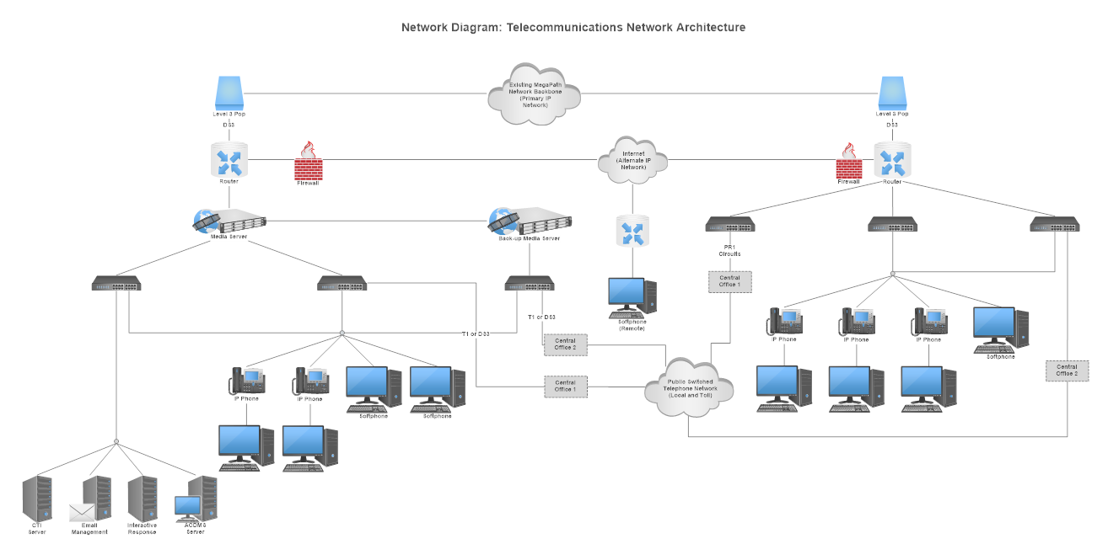

Key services include client-facing applications, internal administration interfaces, development operations, and analytics.

Core functionalities are facilitated through a combination of cloud-hosted services, including [Insert summary of SaaS technologies used]

The architecture supports continuous integration and deployment (CI/CD), with [If you have a development pipeline, summarise the tools here].  
  
The system's resilience is critical for maintaining uptime and ensuring data integrity for all stakeholders involved in the moving process.

# Invocation Process

The following steps outline the process to declare a disaster and activate the disaster recovery plan formally:

|  |  |
| --- | --- |
|  | The incident lead (typically the Head of Engineering) will assess the incident to determine if it meets the criteria for a disaster declaration. |
|  | The incident lead will confer with the DR team members to review the assessment and gain consensus on formally declaring a disaster. |
|  | If the event meets the disaster declaration criteria, the incident lead will formally activate the DR plan and turn incident management over to the DR team. |
|  | The incident lead will notify senior management of the disaster declaration and DR activation. |
|  | The DR team will follow the procedures and checklists outlined in the DR plan to recover critical systems and functions. |
|  | External partners and vendors will be engaged as needed to provide additional resources and capabilities. |
|  | The DR team will execute the communications plan to inform impacted stakeholders of progress. |
|  | Once critical systems have been recovered, the DR team will initiate efforts to restore wider operations. |
|  | The incident lead will perform a formal handoff back to normal operations once DR objectives have been met. |
|  | A deactivation of the DR plan will be communicated, and a retrospective will be conducted to identify improvements. |

# Risk Assessments

|  |  |  |  |  |  |  |  |
| --- | --- | --- | --- | --- | --- | --- | --- |
| Hosting Provider | Service Component | Critical Service | Potential Risks | Likelihood | Impact | Resilience Strategy | Priority Sequence |
| Microsoft | Office 365 | Email, Documents | Service outages, Data breaches, Phishing attacks | Moderate | High | Multi-geo redundancy, Regular backups, MFA | High |
| Sage | Sage Payroll | Payroll Services | Data loss, Unauthorized access, Service downtime | Low | High | Regular backups, Role-based access control | High |
| SAP | ERP System | Business Operations | Data corruption, System failures, Cyber attacks | Moderate | High | High Availability, Regular backups, Patch management | High |
| Salesforce | CRM | Customer Management | Data breaches, Service interruptions, Unauthorized access | Low | High | Multi-region failover, Regular security audits, Data encryption | High |
| Amazon (AWS) | EC2 | Hosting | Server downtime, Data loss, Security breaches | Low | High | Auto-scaling, Snapshots, Security groups | High |
| Google | G Suite | Email, Documents | Service outages, Data breaches, Unauthorized access | Moderate | High | Geo-redundancy, Regular backups, MFA | High |
| Oracle | Oracle DB | Database Services | Data corruption, Unauthorized access, Service interruptions | Moderate | High | Data replication, Encryption, Regular backups | High |
| Intuit | QuickBooks | Accounting | Data loss, Unauthorized access, Service downtime | Low | Moderate | Regular backups, Role-based access control | Medium |
| Atlassian | Jira | Project Management | Service outages, Data breaches, Unauthorized access | Low | Moderate | Regular backups, Security patches, Data encryption | Medium |
| Dropbox | Cloud Storage | File Storage | Data loss, Unauthorized access, Service outages | Low | High | Multi-region replication, Encryption, Regular backups | High |
| Microsoft | Office 365 | Email, Documents | Service outages, Data breaches, Phishing attacks | Moderate | High | Multi-geo redundancy, Regular backups, MFA | High |

**Likelihood** is rated as:

* **High**: Event is expected to occur frequently.
* **Moderate**: Event might occur occasionally.
* **Low**: Event is unlikely to ever occur.

**Impact** is rated as:

* **High**: Event would have a serious impact on operations or would cause a significant financial loss.
* **Moderate**: Event would cause a noticeable disruption and require management attention.
* **Low**: The event would cause minimal disruption.

**Resilience Strategies**

* **High Availability**: Ensures that the service is distributed across different physical and virtual servers, reducing the chance of a single point of failure.
* **Backups**: Regularly scheduled backups that can be used to restore data to a point-in-time should data corruption or loss occur.
* **Multi-AZ Failover**: Utilisation of multiple availability zones within the same region to provide failover capabilities.
* **Geo-Redundancy**: Storing data in geographically diverse locations to protect against regional disasters.
* **Version Control & Backups**: Use of version control systems for code and infrastructure, combined with backups for critical configurations.
* **Dyno Redundancy**: In Heroku, dynos can automatically recover from hardware failures, and using more than one dyno can provide redundancy.
* **Platform's Built-in Redundancy**: Reliance on the inherent resilience and redundancy features provided by the platform (e.g., GitHub, CircleCI, Slack).
* **DNS Failover**: The capability to switch traffic from the failing site to a backup site in case of an outage.
* **Data Export**: Regular exports of data and reports to ensure that analytics data can be recovered in case of a loss of service.

Disaster Recovery Team

The following are the key staff that will co-ordinate the recovery of the services and report into the Disaster Management Team members.

|  |  |  |  |
| --- | --- | --- | --- |
| **Name** | **Role** | **Contact Details** | **Responsibilities** |
|  |  |  |  |
|  |  |  |  |
|  |  |  |  |
|  |  |  |  |

Key External Contacts

The following are the contact details for any 3rd parties that may be needed in the event of execution of part or all of the DRP.

|  |  |  |  |
| --- | --- | --- | --- |
| **Organisation** | **Role** | **Contact Details** | **Comments** |
| ICO – Information Commissioner's Office (UK) | Legislative oversight of GDPR / DPA data | [Self-assessment & Reporting guide](https://ico.org.uk/for-organisations/report-a-breach/personal-data-breach/)  **0303 123 1113** | To report any major breaches to sensitive personal data under GDPR / DPA |
| Insurance | Insurance Company |  | Details on insurance policy held here |
| Reliance ACSN | Cyber-attack response experts | <https://relianceacsn.co.uk/consulting/incident-response/> | Can offer support with how to approach major cyber attack issues (e.g. Ransomware, etc). |
|  |  |  |  |
|  |  |  |  |
|  |  |  |  |
|  |  |  |  |
|  |  |  |  |
|  |  |  |  |
|  |  |  |  |
|  |  |  |  |
|  |  |  |  |
|  |  |  |  |
|  |  |  |  |
|  |  |  |  |

Hierarchy of Notifications

The following summarises who will be responsible for contacting and communicating with whom in the event of a disaster.

# Comms Plan

## Contact list - Key Stakeholders

|  |  |  |  |
| --- | --- | --- | --- |
| **Name** | **Role** | **Communication Method** | **Communication Owner** |
|  |  |  |  |
|  |  |  |  |
|  |  |  |  |
|  |  |  |  |

# Testing

|  |  |  |  |
| --- | --- | --- | --- |
| **Component** | **Testing Approach (paper / backup test / failover)** | **Date of last test** | **Instructions confirmed** |
|  |  |  |  |
|  |  |  |  |

# Document Maintenance

The Disaster Recovery Plan will be

To ensure the disaster recovery plan remains up-to-date, it will be reviewed and updated regularly as changes occur.

* The disaster recovery plan will be reviewed in full on an annual basis by the Head of Engineering.
* Any significant changes to systems, processes, or contracts should trigger a DR plan review.
* The following items will be reviewed for accuracy and updated as needed during DR plan maintenance:
  + Contact details for disaster recovery team members and key stakeholders
  + System inventory and architecture
  + Business impact analysis and risk assessments
  + Recovery procedures and instructions
  + DR invocation process
  + Testing schedule
  + Contracts and SLAs with vendors
  + Appendix documents like server specs, credentials, checklists
* The DR plan review will also be completed after any DR invocation, test, or change in recovery facilities to incorporate lessons learned.
* Any changes to the DR plan will be communicated to relevant stakeholders.

APPENDICIES

# Key Reference Materials

|  |  |
| --- | --- |
| **Description** | **Location** |
| Cyber Response Plan |  |
| Cyber insurance response policy |  |
| System Passwords and keys |  |

# Vendor SLA Agreements

# Important Information

|  |  |
| --- | --- |
| **Item** | **Note** |
| Passwords | Stored in LastPass? |
|  |  |
|  |  |

# Backup Summaries

|  |  |
| --- | --- |
| System |  |
| Owner |  |
| Risk Assessment |  |
| Backup Strategy |  |

# Recovery Procedures

Procedure A

|  |  |  |
| --- | --- | --- |
| Step | Action | Owner |
|  |  |  |
|  |  |  |

Procedure B

|  |  |  |
| --- | --- | --- |
| Step | Action | Owner |
|  |  |  |
|  |  |  |

Key Records & Contracts

|  |  |  |
| --- | --- | --- |
| Record | Primary Location | Alternative Location |
| Cyber insurance |  |  |